Lizard Behavioral training – plus maze

# Pre-checks:

* **Turn ON screens, heater in behavior room, load worms into feeders, plug in 5V,24V power supplies**
* Check Neuralynx PC is ON, Digital Lynx is ON, TTL control box ON and “enabled”. In that order
* Load all feeders with worms (small ones)
* **Place animal in starting arm**
* Open Plesxon Studio v3. Check Plexon tracking: open relevant setting file
  + Test plexon tracking with animal inside starting arm
* Start New Cheetah session, no event window. Config file “cheetah574_20180416.cfg”, Wait until loads completely
* Open Labbok in relevant animal file. Connect Labbook with cheetah:
  + external functions->cheetah->connect
  + open /reset counters
  + external connections->cheetah->cheetah interactions
* make sure maze doors are in correct position
* Pylon cameras ready:
  + First check all cameras are properly connected by opening Pylon configurator and confirming all cameras are present and no X signs appear on their icons.
  + Open shortcut to “startup5_cams_0.27_April2018_plus.bat” file. If open, double click “stop” on each camera until line “camera initialized” appears
* Turn OFF terraria room lights- they will mess with tracking when behavior room door is opened

# Starting the recording (order is important):

* Start cheetah recording (from Labbook)->ACQ->Record
* Start Plexon recording: give meaningful file name: YYMMDD_animal#_experiment#
* Check Pylon cameras are all running and showing the same frame number
* Start behavioral session

# Trials procedure

* If first time in the arena for the animal, start at center with all doors closed and open the correct arm for each trial. (arm 2 for place, or counter clock wise for response)
* **Before trial start:**
  + Animal in starting arm with arm closed, all other arms open
  + Check correct sensor in ON and rest are OFF
  + Check target arm is ON and rest are OFF
* Start trial by opening starting arm; wait for lizard to choose an arm.
* Mark choice, if no choice is made within 2 minutes- nudge the animal to the center and mark the choice. If no response mark center as choice.
* Mark chosen arm in trials sheet. Write down any unusual things that lizard did or happened during the trial (e.g. mechanical failures). Repeat until animal is full /not responding/out of rewards.

**Control box overview:**

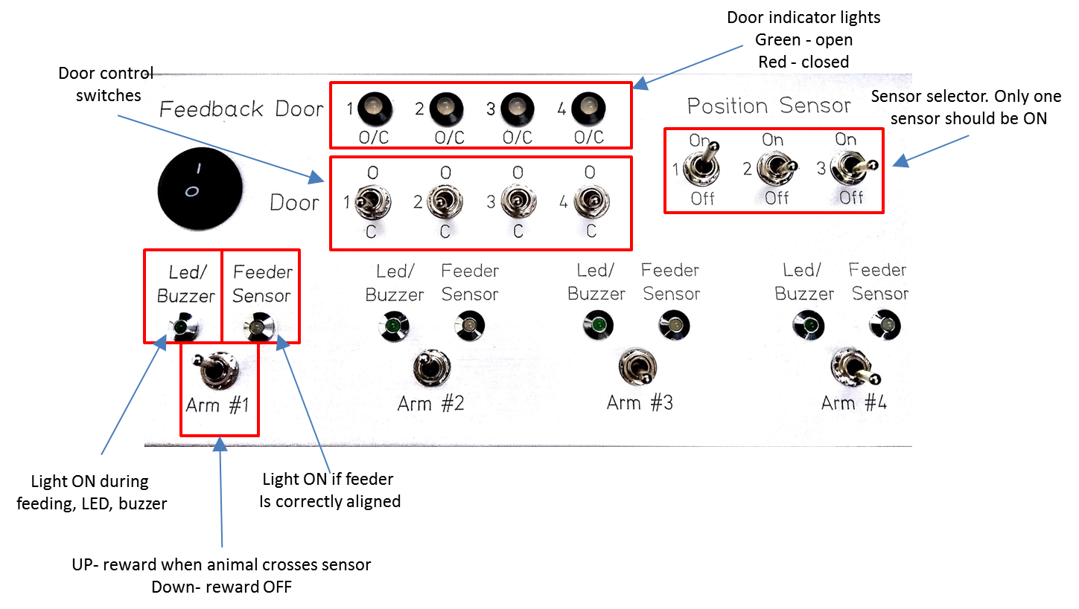

# Ending the recording (order is important):

* Stop Plexon recording – use top stop sign to stop all cameras at once
* Stop cheetah (from Labbook)->stop record->stop ACQ, Close cheetah window
* Disconnect Labbok from cheetah, save counters and reset them
* **Stop Pylon cameras- double click “stop” on each camera window**
* **Remove animal from arena**
* Rename last cheetah folder in **C:\cheetah_data\YYYYMMDD_animal#_session#**
  + Create new folder in ”**Data3\WeissShahaf\PlusMaze\animal#\YYMMDD#\time#_”cheetah”**
  + Copy cheetah data to new Data3 folder …**_”cheetah”**
  + Copy plexon .dvt and .avi files to a Data3 folder ending with **“…videos”**
  + Rename basler camera files- YYMMDD_animal#_experiment#
  + Add to FormatFactor conversion list (**custom**->DIVX avi 50%)
  + change output folder to videos folder
  + Start conversion at the end of recording day
* Fill in details in excel inclusion list
* **Clean arena- rubber with ETH, acrylic windows with window cleaner- not ETH!**
* **If last session of the day: Turn OFF heater in behavior room, remove worms from feeders, turn OFF screens, DISCONNECT ARENA POWER SUPPLY- 5V, shut down 24V under arena**
* ***Wash your hands before moving to the next animal / exiting the room***